**Cycle-1**

1. Print your name to the screen with every letter being a different heading size

Answer:

<html>

<head>

<title></title>

</head>

<body>

<h1>H</h1><h2>A</h2><h3>R</h3><h4>I</h4><h5>T</h5><h6>H</h6><h7>A</h7>

</body>

</html>

Output:

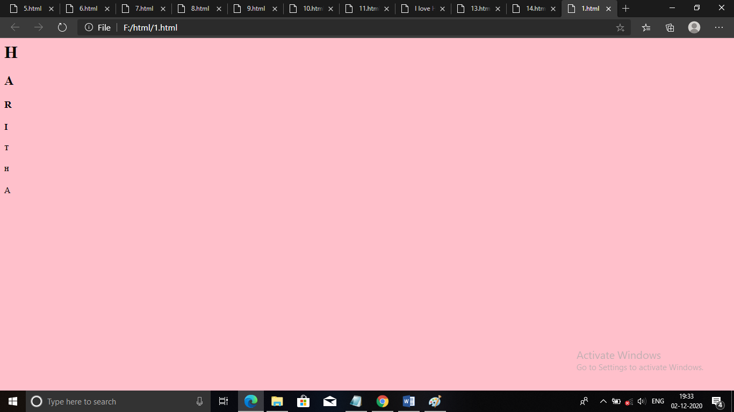

1. Display the following text:

H2O

12th April 2016

HTML stands for ~~High Text Markup Language~~

He said <**I am fine**>

Answer:

<html>

<head>

<title> </title>

</head>

<body>

<h5>H20</h5>

<p> 12th April 2016</p>

<p> HTML stands for hyper text markup language</p>

<p>He said <'I am fine'></p>

</body>

</html>

Output:

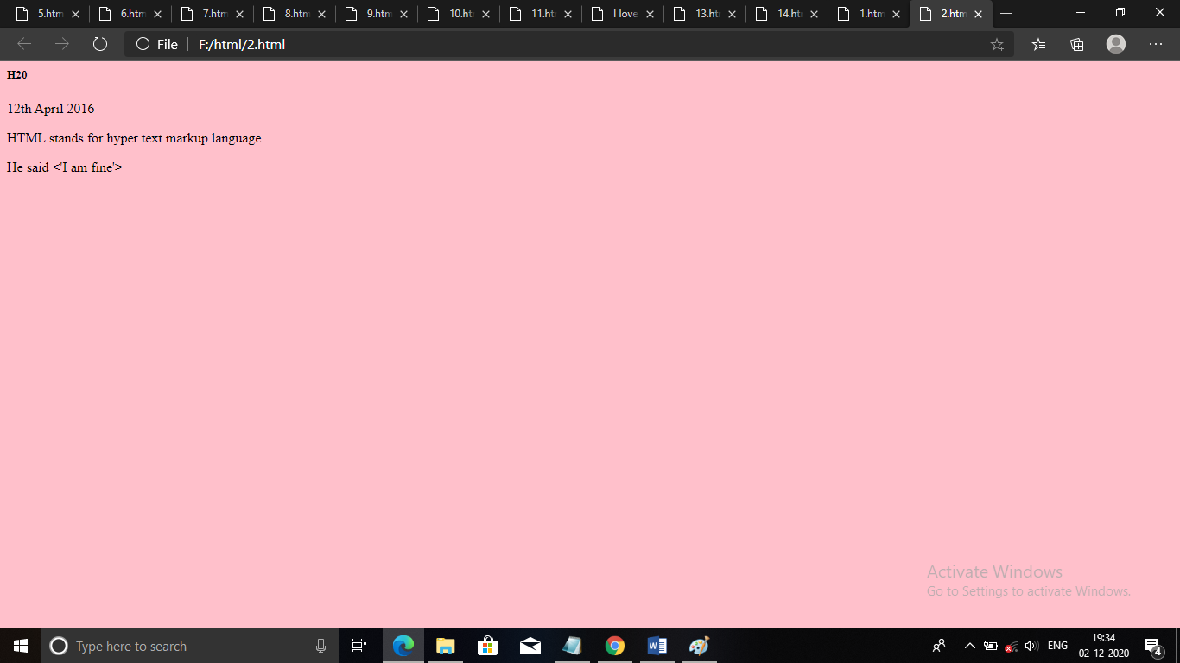

1. Print a paragraph with 4 - 5 sentences. Each sentence should be a different font.

Answer:

<html>

<head>

<title> </title>

</head>

<body bgcolor="pink">

<h1>HTML</h1>

<p> <font face="Tahoma"> HTML, in full hypertext markup language</font></p>

<p> <font face="Courier New">A formatting system for displaying material retrieved over the internet.</font></p>

<p> <font face="Helvetica">Each retrieval unit is known as a web page(from www)</font></p>

<p> And such pages frequently contain hypertext links that allow related pages to be retrieved.</p>

</body>

</html>

Output:

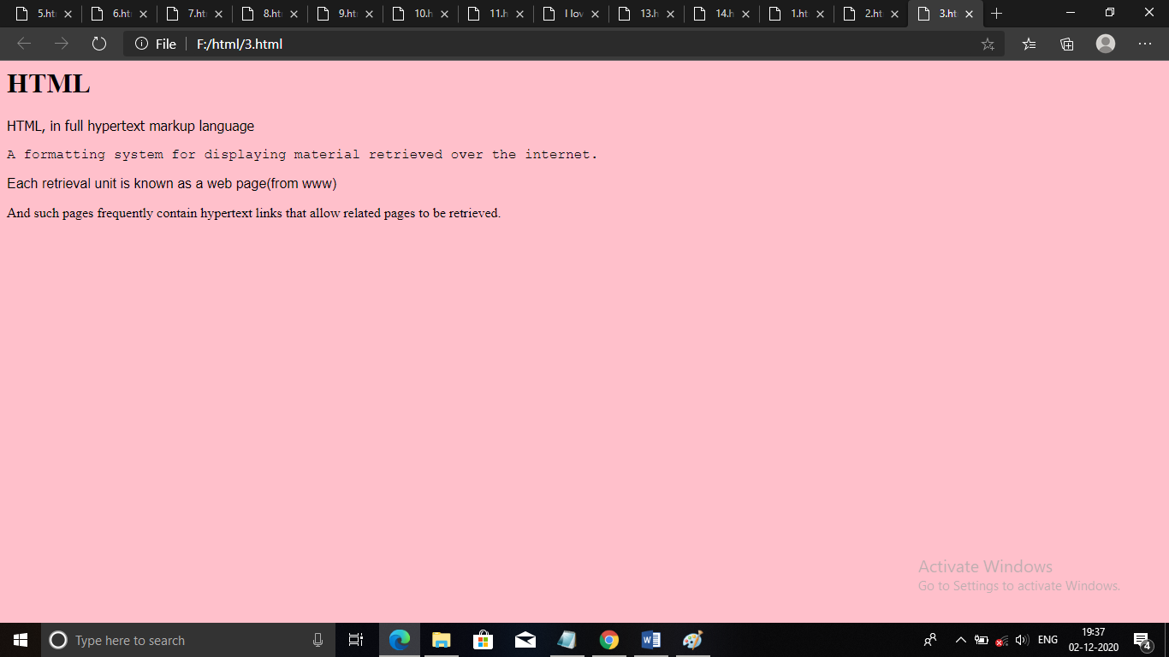

1. Print a paragraph that is a description of a book, include the title of the book as well as its author. Names and titles should be underlined, adjectives should be italicized and bolded

Answer:

<html>

<head>

<title> </title>

</head>

<body bgcolor="pink">

<h1><u>EMMA</u></h1>

<h3><u> Novel by Jane Austen</u></h3>

<p> Emma,by jane austen ,is a novel about youthful hubris and romantic misunderstandings.</p>

It is set in the fictional country village of highbury and the surrounding estates of hartfield,

<p>Randalls and Donwell Abbey,and involves the relationships among people from a small number of families.</p>

<i>Characters:Emma,George,Jane,Frank,Harriet,Mr.Elton,more.</i>

</body>

</html>

Output:

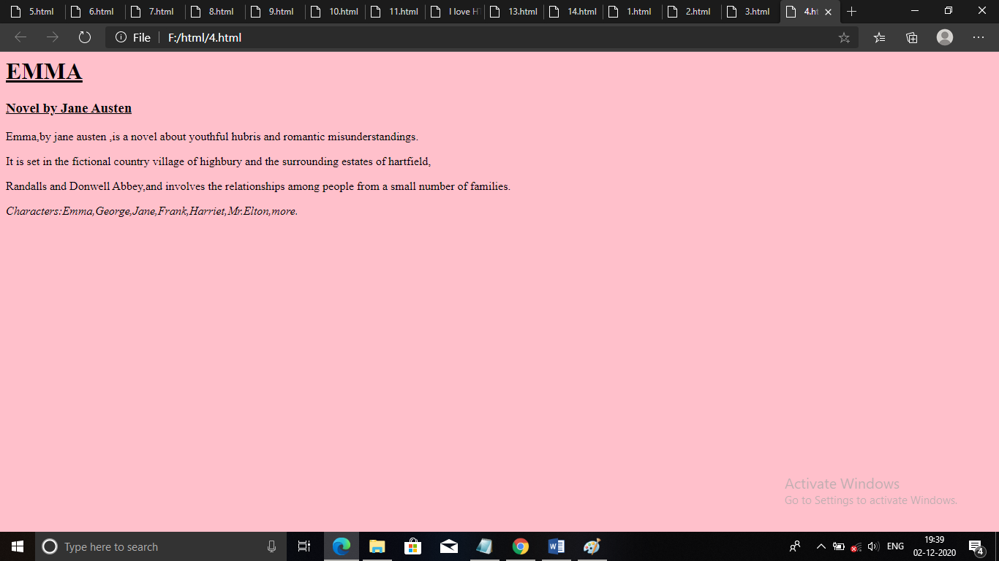

1. Print two lists with any information you want. One list should be an ordered list, the other list should be an unordered list.

Answer:

<html>

<head>

<title> </title>

</head>

<body bgcolor="pink">

<h1>Unorderd List</h1>

<ul>

<li>html</li>

<li>css</li>

<li>java script</li>

</ul>

<h1>orderd List</h1>

<ol>

<li>css</li>

<li>html</li>

<li>java script</li>

</ol>

</body>

</html>

Output:

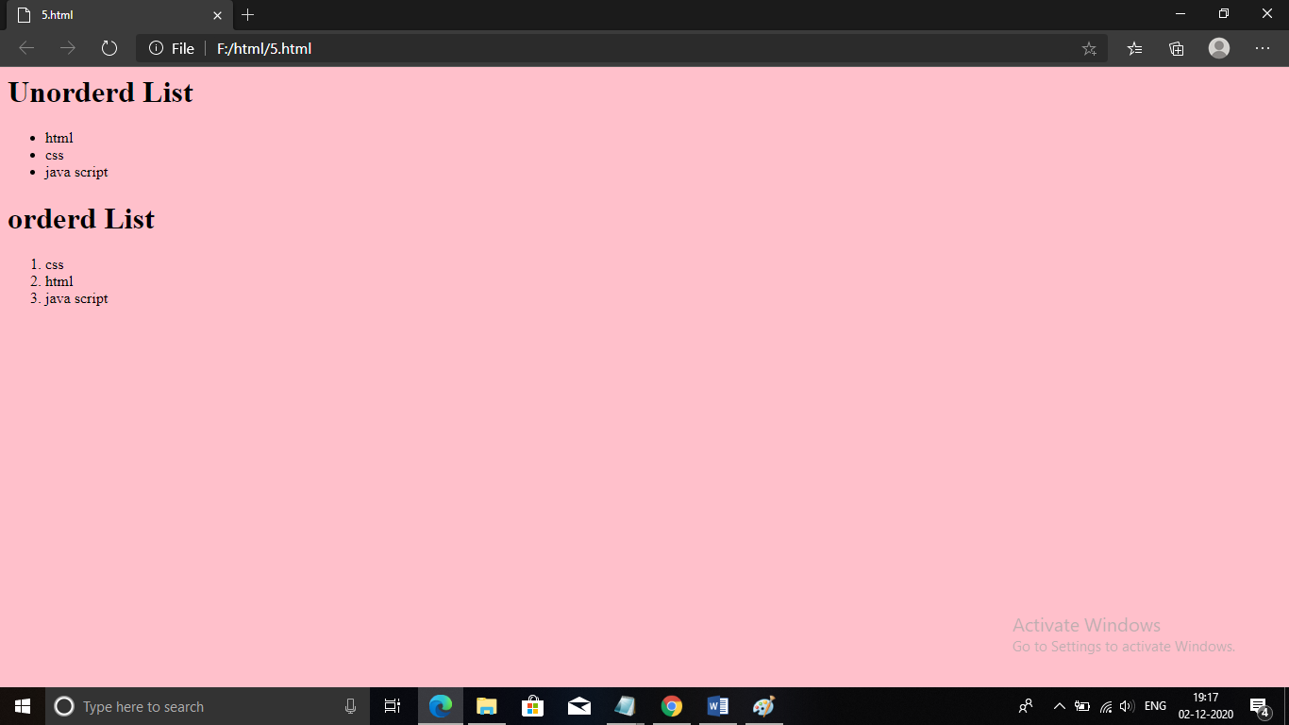

1. Prints 10 names with a line break between each name. The list should be alphabetized, and to do this place a subscripted number next to each name based on where it will go in the alphabetized list. (Example: Alan1). Print first, the unalphabetized list with a subscript number next to each name, then the alphabetized list. Both lists should have an <h1> level heading

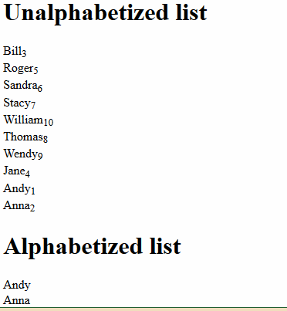

Answer:

<html>

<head>

<title> </title>

</head>

<body bgcolor="pink">

<h2>Unalphaqbetized list</h2>

<ol>

<li>Bill3</li>

<li>Roger5</li>

<li>Sandra6</li>

<li>Stacy7</li>

<li>William10</li>

<li>Thomas8</li>

<li>Wendy9</li>

<li>Jane4</li>

<li>Andy1</li>

<li>Anna2</li>

</ol>

<h2>Alphaqbetized list</h2>

<ol type="a">

<li>Andy1</li>

<li>Anna2</li>

<li>Bill3</li>

<li>Jane4</li>

<li>Roger5</li>

<li>Sandra6</li>

<li>Stacy7</li>

<li>Thomas8</li>

<li>Wendy9</li>

<li>William10</li>

</ol>

</body>

</html>

Output:

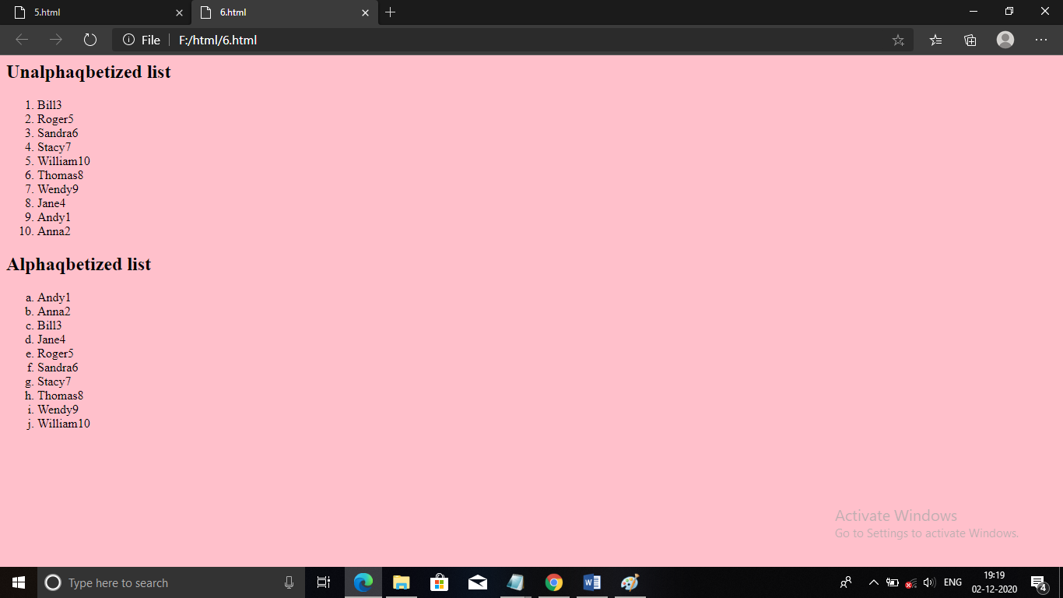

1. Print the squares of the numbers 1 - 20. Each number should be on a separate line, next to it the number 2 superscripted, an equal sign and the result

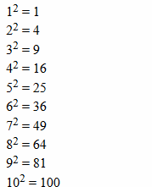

Answer:

<html>

<head>

<title> </title>

</head>

<body bgcolor="pink">

1<sup>2</sup>=1

<br>

2<sup>2</sup>=4

<br>

3<sup>2</sup>=9

<br>

4<sup>2</sup>=16

<br>

5<sup>2</sup>=25

<br>

6<sup>2</sup>=36

<br>

7<sup>2</sup>=49

<br>

8<sup>2</sup>=64

<br>

9<sup>2</sup>=81

<br>

10<sup>2</sup>=100

<br>

11<sup>2</sup>=121

<br>

12<sup>2</sup>=144

<br>

13<sup>2</sup>=169

<br>

14<sup>2</sup>=196

<br>

15<sup>2</sup>=225

<br>

16<sup>2</sup>=256

<br>

17<sup>2</sup>=289

<br>

18<sup>2</sup>=324

<br>

19<sup>2</sup>=361

<br>

20<sup>2</sup>=400

</body>

</html>

Output:

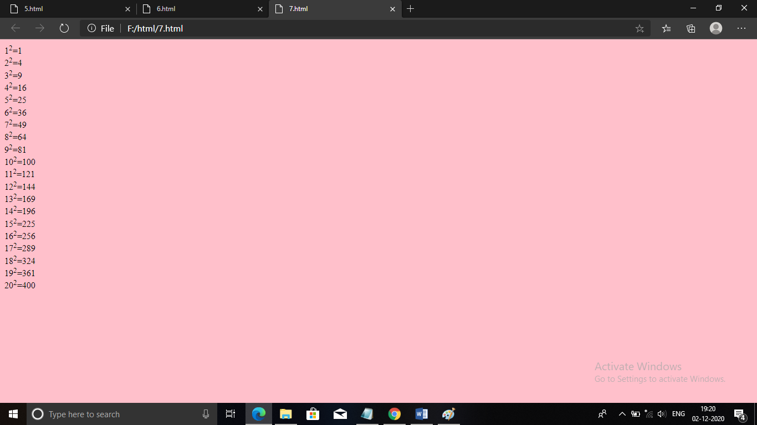

1. Print a definition list with 5 items.

Answer:

<html>

<head>

<title> </title>

</head>

<body bgcolor="pink">

<dl>

<dt>Computer:</dt>

<dd>

A computer is a machine that can be instructed to carry out sequences of arithmetic or logical operations automatically via computer programming.

Modern computers have the ability to follow generalized sets of operations, called programs.

These programs enable computers to perform an extremely wide range of tasks.

A "complete" computer including the hardware, the operating system (main software), and peripheral equipment required and used for "full" operation can be referred to as a computer system.

This term may as well be used for a group of computers that are connected and work together, in particular a computer network or computer cluster.

</dd>

</dl>

<dl>

<dt>HTML:</dt>

<dd>

Hypertext Markup Language (HTML) is the standard markup language for documents designed to be displayed in a web browser.

It can be assisted by technologies such as Cascading Style Sheets (CSS) and scripting languages such as JavaScript.

Web browsers receive HTML documents from a web server or from local storage and render the documents into multimedia web pages.

HTML describes the structure of a web page semantically and originally included cues for the appearance of the document.

</dd>

</dl>

<dl>

<dt>CSS:</dt>

<dd>

Cascading Style Sheets (CSS) is a style sheet language used for describing the presentation of a document written in a markup language such as HTML.[1] CSS is a cornerstone technology of the World Wide Web, alongside HTML and JavaScript.

CSS is designed to enable the separation of presentation and content, including layout, colors, and fonts.

This separation can improve content accessibility, provide more flexibility and control in the specification of presentation characteristics, enable multiple web pages to share formatting by specifying the relevant CSS in a separate .css file which reduces complexity and repetition in the structural content as well as enabling the .css file to be cached to improve the page load speed between the pages that share the file and its formatting.

</dd>

</dl>

<dl>

<dt>Javascript:</dt>

<dd>

JavaScript often abbreviated as JS, is a programming language that conforms to the ECMAScript specification.

JavaScript is high-level, often just-in-time compiled, and multi-paradigm. It has curly-bracket syntax, dynamic typing, prototype-based object-orientation, and first-class functions.

Alongside HTML and CSS, JavaScript is one of the core technologies of the World Wide Web. JavaScript enables interactive web pages and is an essential part of web applications.

The vast majority of websites use it for client-side page behavior,and all major web browsers have a dedicated JavaScript engine to execute it.

</dd>

</dl>

<dl>

<dt>Python:</dt>

<dd>

Python is an interpreted, high-level and general-purpose programming language. Python's design philosophy emphasizes code readability with its notable use of significant whitespace.

Its language constructs and object-oriented approach aim to help programmers write clear, logical code for small and large-scale projects.

Python is dynamically typed and garbage-collected. It supports multiple programming paradigms, including structured (particularly, procedural), object-oriented, and functional programming.

Python is often described as a "batteries included" language due to its comprehensive standard library.

</dd>

</dl>

</body>

</html>

Output:

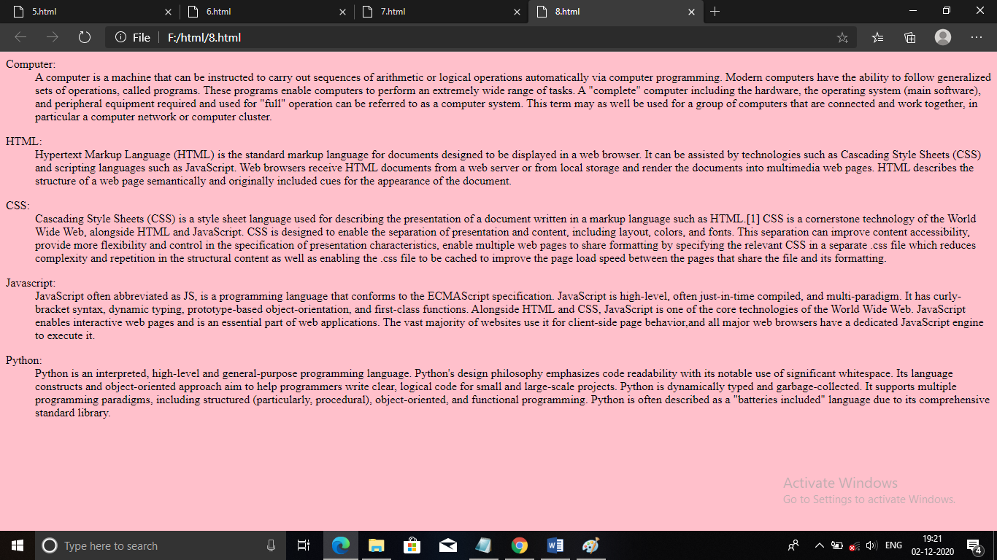

1. Display an image that has a border of size 2, a width of 200, and a height of 200.

Answer:

<html>

<head>

<title> </title>

</head>

<body bgcolor="pink">

<img src="cat.jpg" alt="fg" style width="200%" height="200%" border="2">

</body>

</html>

Output:

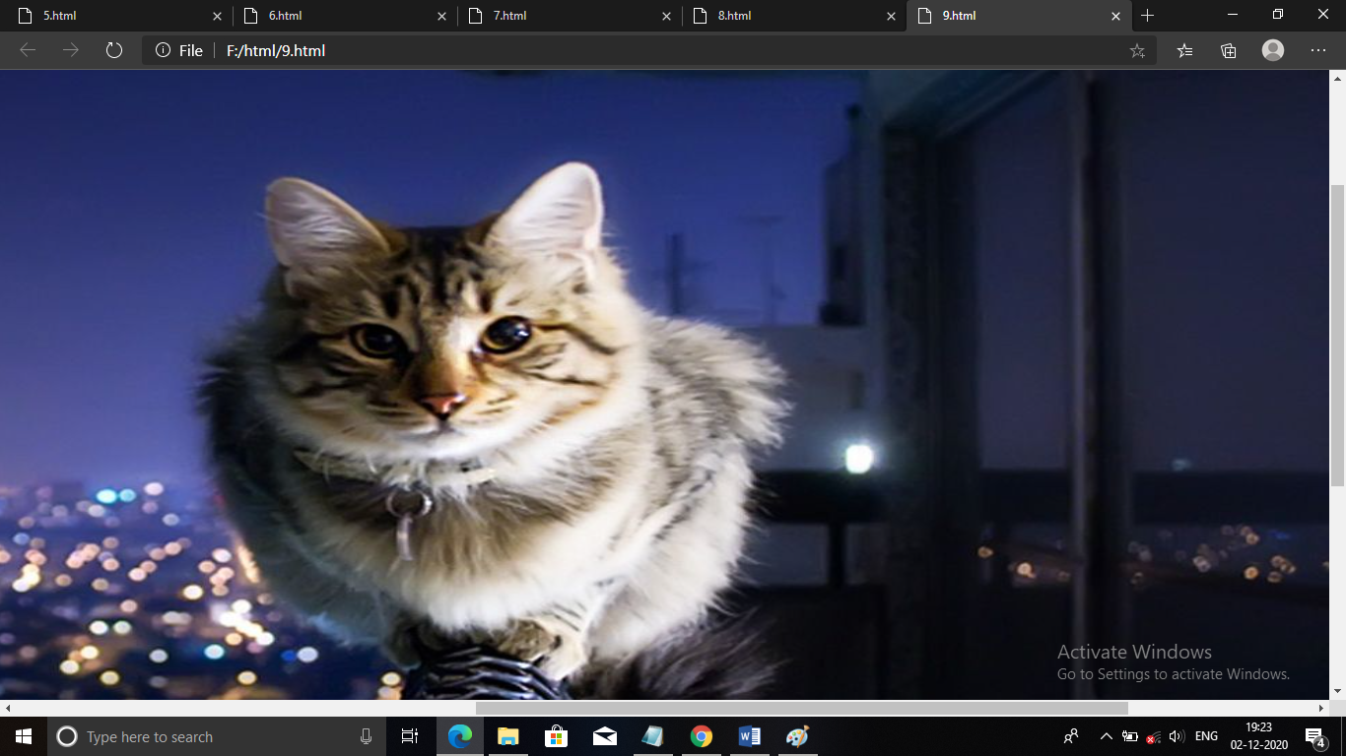

1. Print ten acronyms and abbreviations of your choosing, each separated by two lines. Specify the data that the abbreviations and acronyms represent

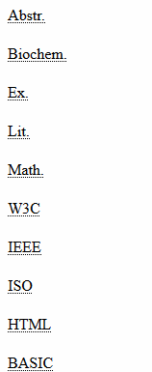

Answer:

<html>

<head>

<title> </title>

</head>

<body bgcolor="pink">

<abbr title="Abstract">Abstr.</abbr>

<br><br>

<abbr title="Biochemistry">Biochem.</abbr>

<br><br>

<abbr title="Example">Ex.</abbr>

<br><br>

<abbr title="Mathematics">Math.</abbr>

<br><br>

<abbr title="World Wide Web Consortium">W3C.</abbr>

<br><br>

<abbr title="Institute of Electronics and Electrical Engineering">IEEE.</abbr>

<br><br>

<abbr title="International Standards Organisation">ISO.</abbr>

<br><br>

<abbr title="Hyper Text Markup Language">HTML.</abbr>

<br><br>

<abbr title="Beginners All Purpose Symbolic Instruction Code">BASIC.</abbr>

<br><br>

</body>

</html>

Output:

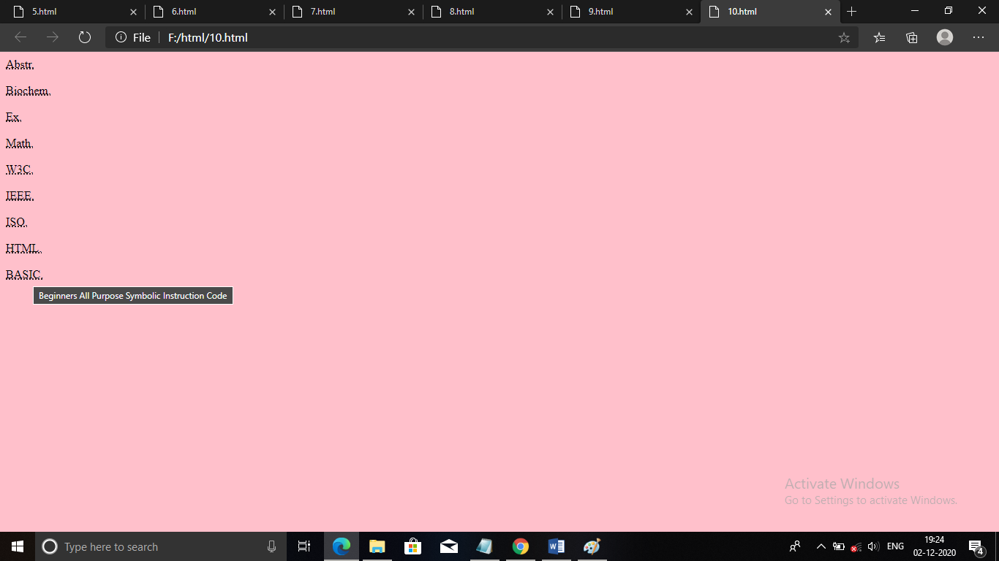

1. Print two addresses in the same format used on the front of envelopes (senders address in top left corner, receivers address in the center

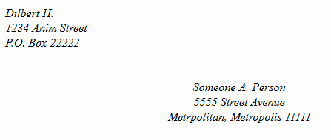

Answer:

<html>

<head>

<title> </title>

</head>

<body bgcolor="pink">

<address>

Dilbert H.<br>

1234 Anim Street<br>

P.O.Box 22222

</address>

<address style align="center">

<br><br><br><br>Someone A.Person<br>

5555 Street Avenue<br>

Metropolitan,Metropolis 11111

</address>

</body>

</html>

Output:

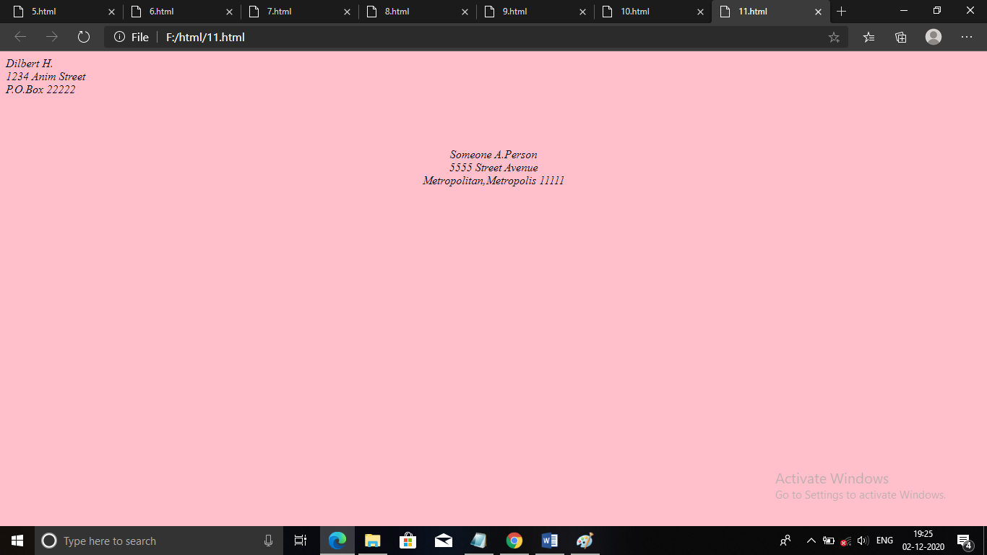

1. Create an HTML page with the following contents:

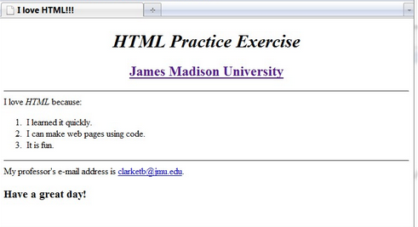

Answer:

<html>

<head>

<title> I love HTML!!!</title>

</head>

<body bgcolor="pink">

<div style align="center">

<h1>HTML Practice Excercise</h1>

<font size="5" color="brown" ><u> James Madison University </u></font>

</div>

<hr color="black">

I love HTML becuase:

<ol>

<li> I learned it quickly</li>

<li> I can make web pages using code.</li>

<li>It is fun.</li>

</ol>

<hr color="black">

My professor's email address is <a href="#">clarktb@jmu.edu.</a>

<h2> Have a great day!</h2>

</body>

</html>

Output:

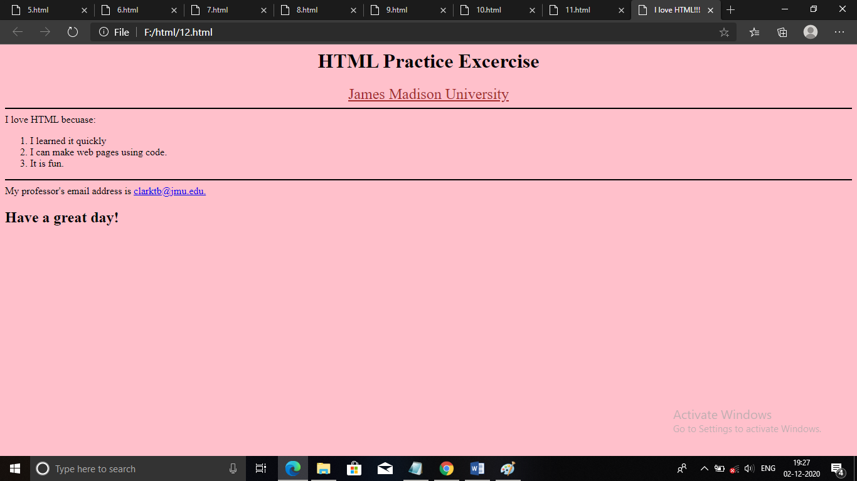

1. Create the following table

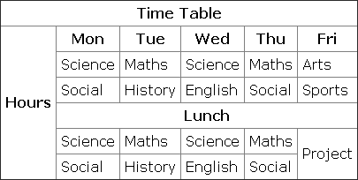

Answer:

<html>

<head>

<title> </title>

</head>

<body bgcolor="pink">

<table border="1">

<tr >

<th colspan="6">Time Table</th>

</tr>

<tr >

<th rowspan="6">Hours</th>

<th>Monday</th>

<th>Tuesday</th>

<th>Wednesday</th>

<th>Thursday</th>

<th>Friday</th>

</tr>

<tr>

<td>Science</td>

<td>Maths</td>

<td>Science</td>

<td>Maths</td>

<td>Arts</td>

</tr>

<tr>

<td>Social</td>

<td>History</td>

<td>English</td>

<td>Social</td>

<td>Sports</td>

</tr>

<tr >

<th colspan="5">Lunch</th>

</tr>

<tr>

<td>Science</td>

<td>Maths</td>

<td>Science</td>

<td>Maths</td>

<td>Arts</td>

</tr>

<tr>

<td>Social</td>

<td>History</td>

<td>English</td>

<td>Social</td>

<td>Sports</td>

</tr>

</table>

</body>

</html>

Output:

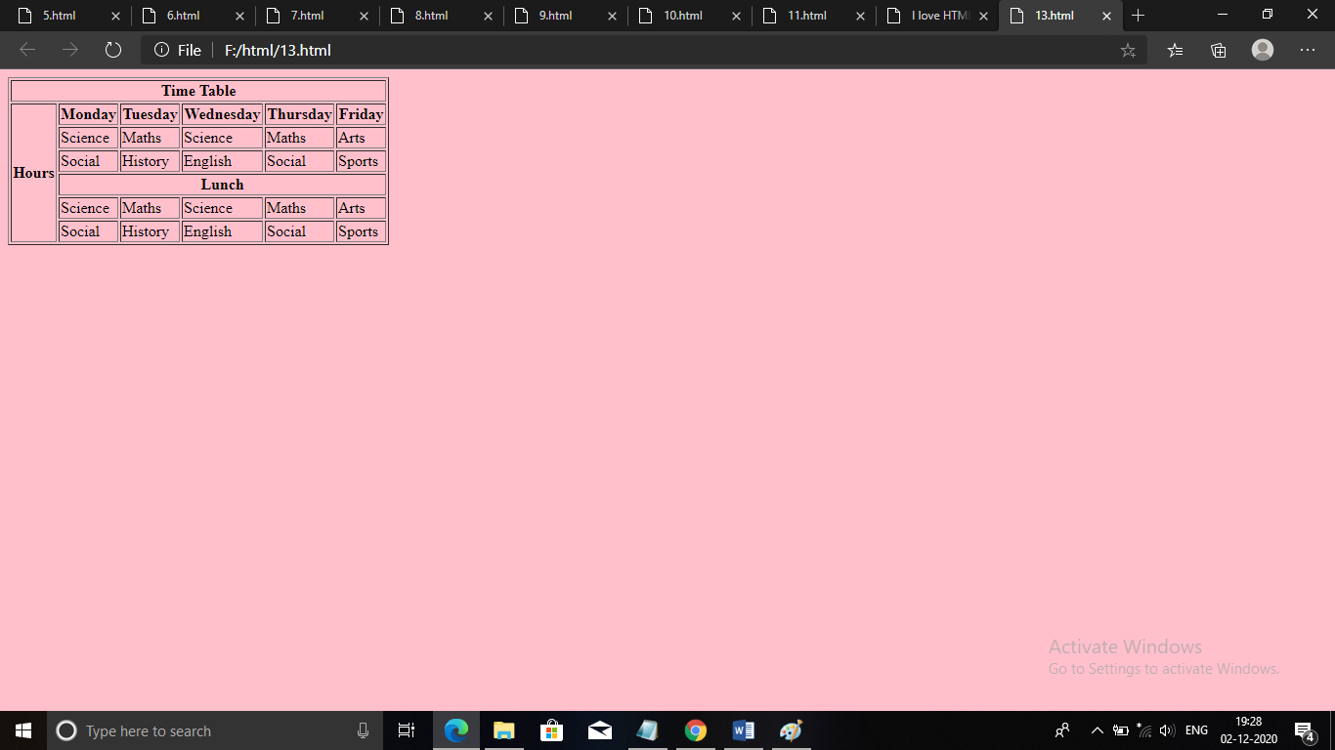

1. Create a HTML Page which looks like the one given below

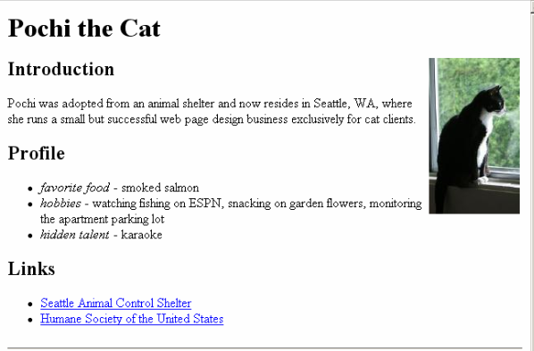

Answer:

<html>

<head>

<title> </title>

</head>

<body bgcolor="pink">

<h1>Pochi the Cat</h1>

<img src="cat.jpg" alt="cat" style align="right" width="250" height="300">

<h2>Indroduction</h2>

<p>Pochi was adopted from animal shelter and now resides in Seattle,WA,where

she runs a small but successful web page design business exclusively for cat clients.</p>

<h2>Profile</h2>

<ul>

<li><i> favorite food </i>- smoked salmon</li>

<li><i>Hobbies</i> - watching fishing on ESPN,snacking on garden flowers.</li>

<li><i>Hidden talent</i> - karaoke</li>

<h2>Links</h2>

<ul>

<li><a href="#"> Seattle Animal Control Shelter</a></li>

<li><a href="#"> Humane Society of the United States</a></li>

</ul>

</body>

</html>

Output:

